* **Lab Task 5:**

Write a SQL query to find those employees who joined in 2001. Return job title, department name, employee name, and joining date of the job.

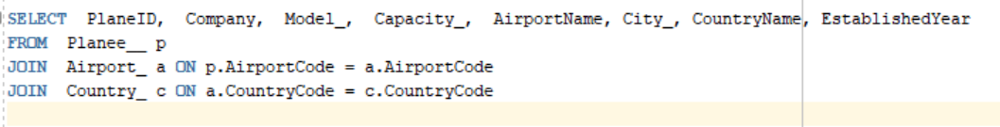

OUTPUT:

